iOS Offline Mobile Signature Sync

Revision History
Author | Revision Number | Date
TCCODER | 1.0 | Feb 09, 2016

Contents
Deployment Instructions 3
1. Organization of Submission 3
2. Environment Requirement 3
3. Starting 3
4. Verification 3
4.1 General notes 3
4.2 Syncing online 4
4.3 Syncing offline (from list) 4
4.4 Syncing offline (from details) 5
5. Resource Contact List 6

Deployment Instructions

Organization of Submission
/src Source code
/docs Documents

Environment Requirement

Mac OS X 10.11 or above
XCode 7.2

Runtime: iOS 8.0 or above device/simulator

Starting
4.1 Open the ‘SFDCOfflinePoc.xcworkspace' file in ‘src’ folder,

4.2 Choose “SFDCOfflinePoc” scheme

4.3 Do a clean:
- From XCode menu : Project -> Clean
- From Simulator menu : iOS Simulator -> Reset Contents and Settings…

4.4 Now run.

Verification

General notes

Login into the app using member@topcoder.com / t0pc0d3r as credentials.

Video overview is located at the root folder of submission, named 'new overview.swf' - you can open it with your browser.

You can check that all signatures are successfully uploaded by going to www.salesforce.com with your browser and login in with same credentials.

Note, that you can only sign submitted (synced at least once) sample requests:
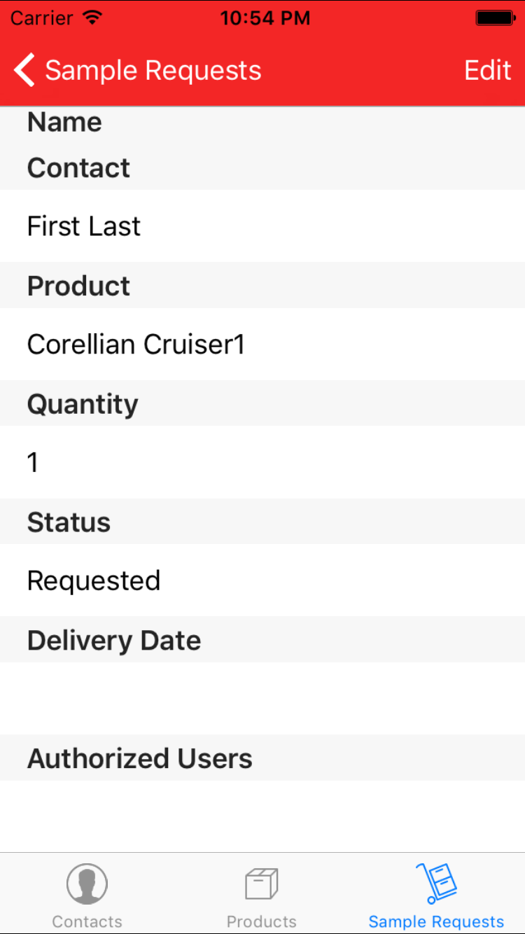

The one on the screenshot was not uploaded yet.

Syncing online

Open a sample request. Draw a signature and press 'Confirm' while online.

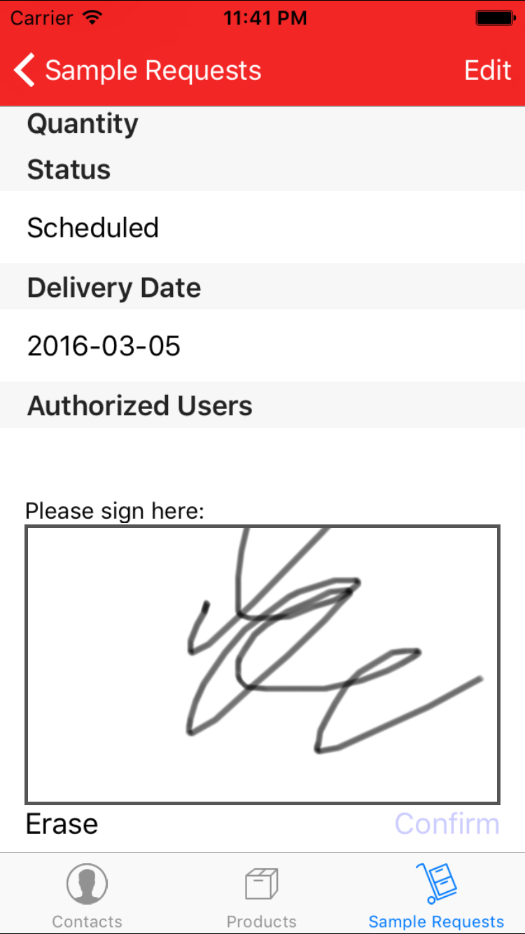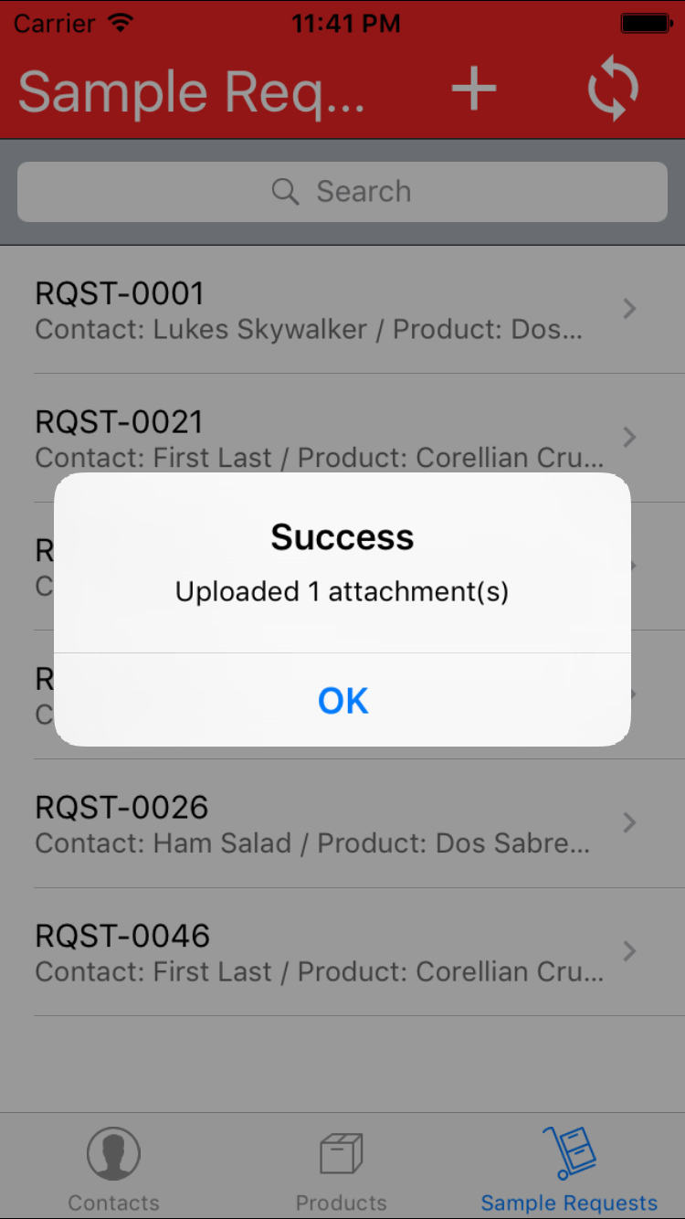

Syncing offline (from list)

Turn off the Internet. Don't enter anything as a PIN and just tap the button on the security alert.
Sign a bunch of requests while offline, note that signed requests are marked for sync:
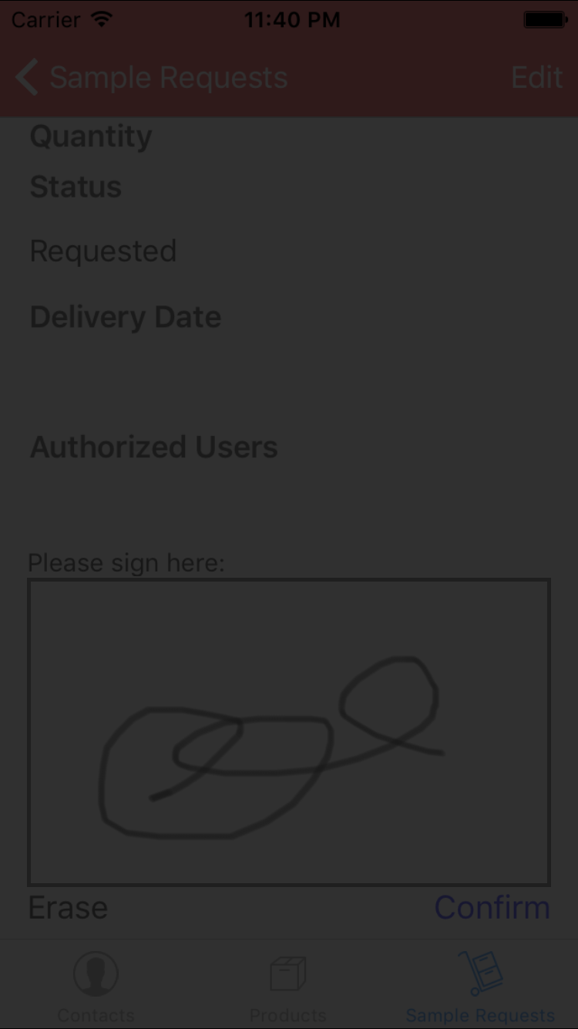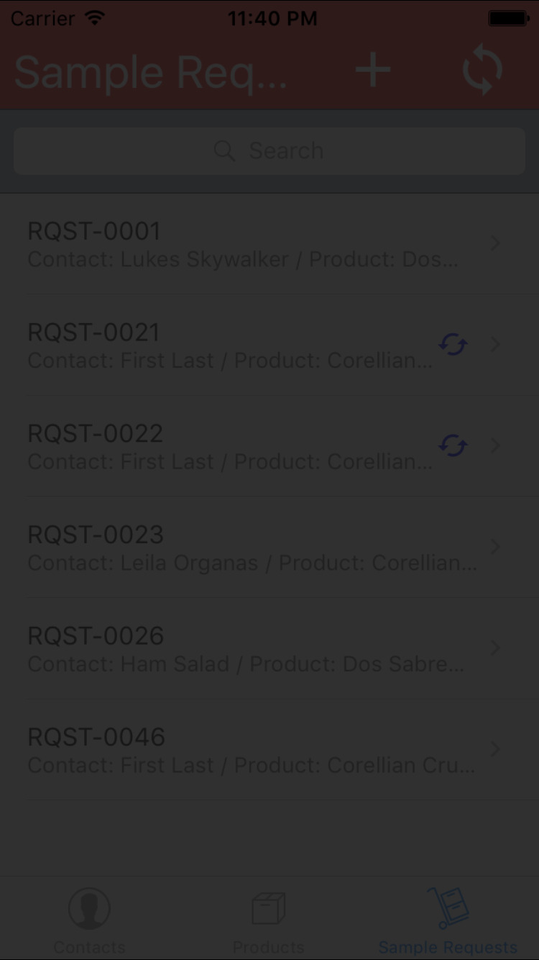

Turn the Internet on. Tap sync button

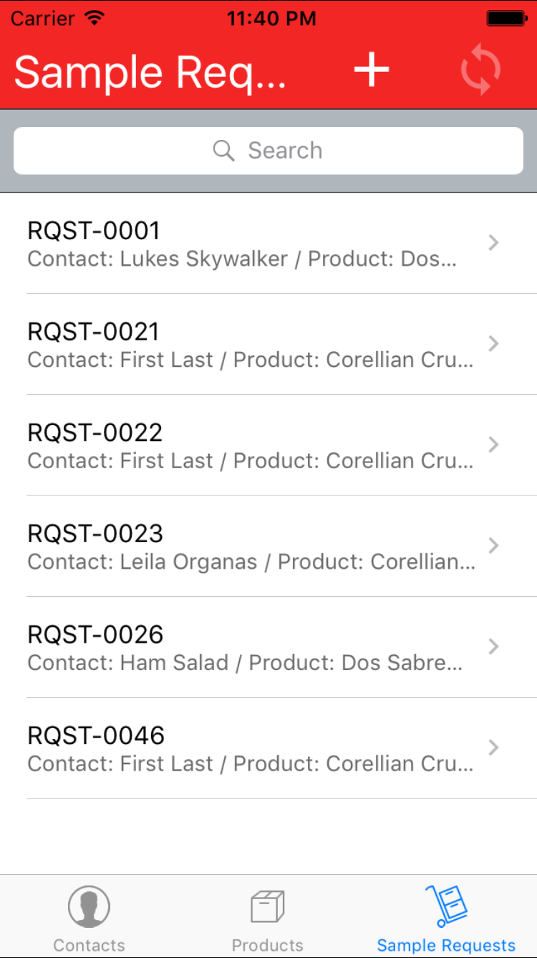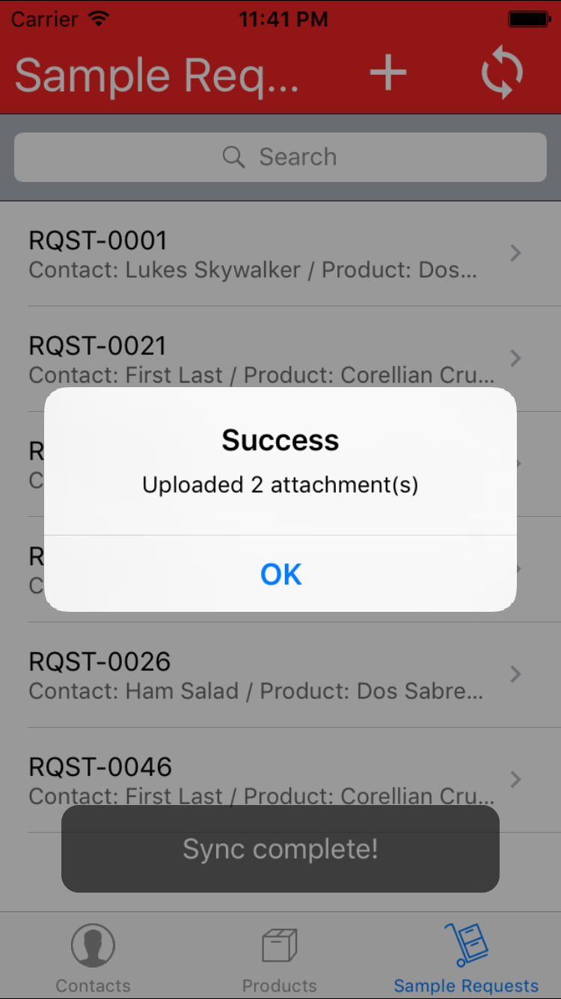

When sync completes you will see number of attachments uploaded (if the number is > 0)

Syncing offline (from details)

Turn off the Internet. Don't enter anything as a PIN and just tap the button on the security alert.
Sign a bunch of requests while offline. Then turn the Internet on and open another request. Sign it and tap 'Confirm':

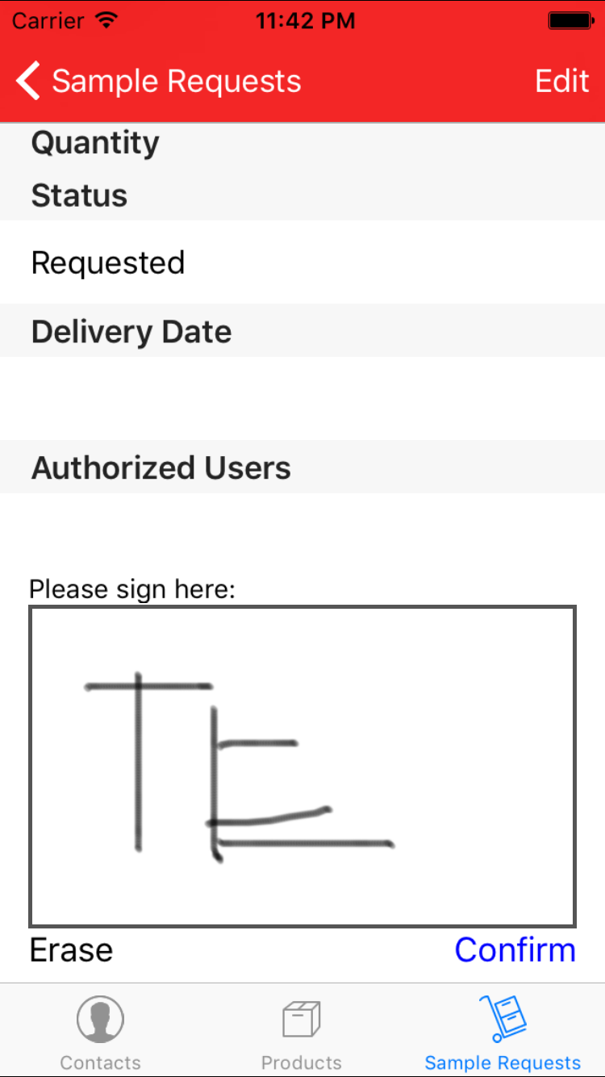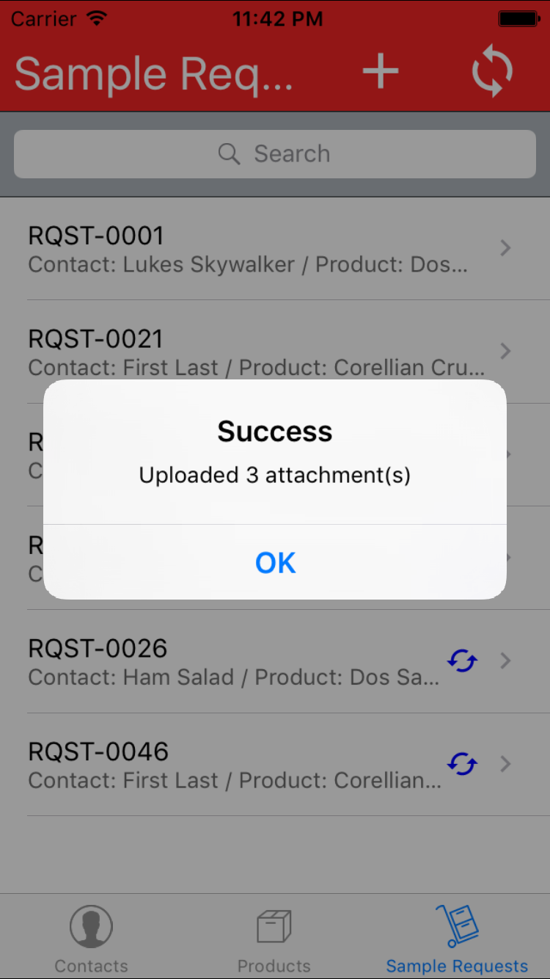

Don't forget to check that all signed requests are successfully uploaded on www.salesforce.com:

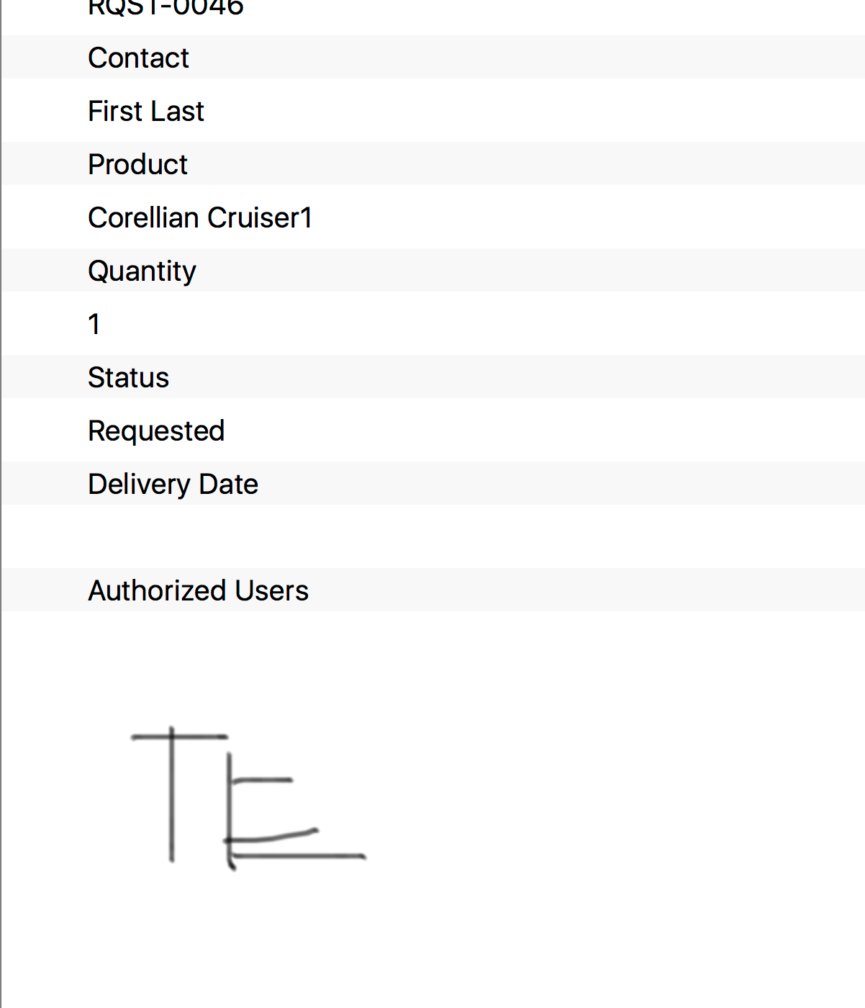

Resource Contact List
Name | Resource Email
TCCODER | Through TopCoder Member Contact

